6

Councillors are hereby summoned to attend a Meeting of GORSLEY & KILCOT PARISH COUNCIL to be held at 7:30pm on Monday 2nd September 2019 in the Upper Room at Christ Church, Gorsley for the purpose of transacting the following business.
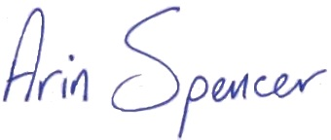

Arin Spencer (Mrs) Dated 28 August 2019
Clerk to Gorsley & Kilcot Parish Council

Members of the Public are invited to address the Council at 7:30pm on matters on the agenda. (Public to speak for a maximum of 3 minutes each with the Public Session being no longer than 30 minutes).

AGENDA

- To RECEIVE Apologies for Absence
- To RECEIVE Declarations of Interest and Requests for Dispensation regarding items on the agenda
- To APPROVE and sign the minutes of the Council meeting held on 1st July 2019 as a correct record.
- Financial Matters:
  - To RECEIVE report from Cllr Price, Lead Member for Finance, on the internal accounts check for April – July 2019.
  - To NOTE Co-op Bank Statement dated 30/07/2019 showing a balance of £11,504.01
  - To RECEIVE and sign Bank Reconciliation as at 30/07/2019
  - To APPROVE Receipts & Payments Account as at 30/07/2019
  - To NOTE Budget Monitoring Statement as at 30/07/2019
  - To APPROVE the following payments as per the Cheque Approval Sheet:
Description | Chq No | Power | Budget | Amount
Clerk’s Salary (July) | SO | LGA 1972 s112(2) | Staff Costs | £ 196.16
Clerk’s Salary (August) | SO | LGA 1972 s112(2) | Staff Costs | £ 196.16
Clerk’s Expenses | 100020 | LG(FP)A 1963 S 5 | Staff Costs | £ 50.61
- Budget 2020/2021
  - To CONSIDER proposed draft Budget for 2020/21
- Planning Matters:
  - To COMMENT on new planning applications received:
    - P0953/19/FUL Quarry Farm, Aston Ingham Road, Kilcot, Newent
Proposal: Construction of an equestrian manege
  - To RECEIVE planning decisions
    - P0750/19/FUL Orchard House, Aston Ingham Road, Kilcot GL18 1NP
Decision: Granted Permission
- To DISCUSS traffic problems on the B4221
- To DISCUSS Registration of Common Land – Aston Common
- TREES
  - To CONSIDER action required in respect of tree safety in the parish
  - To CONSIDER signing up to NALC’s Tree Charter
- To RECEIVE progress report from Cllr Warwick on repair of Kilcot Green Noticeboard
- To CONSIDER hosting a free Community First Aid Course
- To CONSIDER rebuilding Council’s website in WordPress
- To APPROVE the following GAPTC training schedule for the Clerk:
  - Budget Planning & Precept Setting (16-10-19) £15
  - Planning applications from the perspective of town and parish councils (20-11-19) £17
  - Clerk’s Networking with 2 guest speakers (27-11-19) £7
- Clerks Report – FOR INFORMATION ONLY
To RECEIVE a report from the Clerk on actions requested in the minutes dated 1st July 2019 not covered elsewhere in the agenda including action tracker
- To CONSIDER attending the following meetings/events:
  - CPRE AGM 12 September 2019 at 18:30 in Westbury-on-Severn church
  - Dementia Action Alliance Celebration Event 27 September 2019 (GL16 7QT)
- To RECEIVE items for the November meeting agenda
- Next meeting
To CONFIRM that the next ordinary meeting of the Parish Council will be held on 4 November 2019 at 7:30pm in the Upper Room at Christ Church, Gorsley.

PLANNING APPLICATIONS WILL BE AVAILABLE FOR VIEWING BY THE PUBLIC FROM 15 MINUTES PRIOR TO THE MEETING AND BY APPOINTMENT WITH THE CLERK (Mrs Arin Spencer 07484619582) AT CHRIST CHURCH GORSLEY
ALL MEETINGS OF THE COUNCIL ARE OPEN TO THE PUBLIC AND PRESS WITH THE EXCEPTION OF ITEMS CONSIDERED UNDER STANDING ORDER 1C
All meetings can be moved downstairs if stairs are an obstacle to attendance at a meeting or a Loop System is required. A wheelchair ramp can be provided to access the church.
“Members are reminded that the Council has a general duty to consider the following matters in the exercise of any of its functions: Equal Opportunities (race, sexual orientation, marital status and any disability), Crime and Disorder, Biodiversity, Health and Safety and Human Rights.”
51.1 REPORT: Internal Accounts Check (April – July 2019)
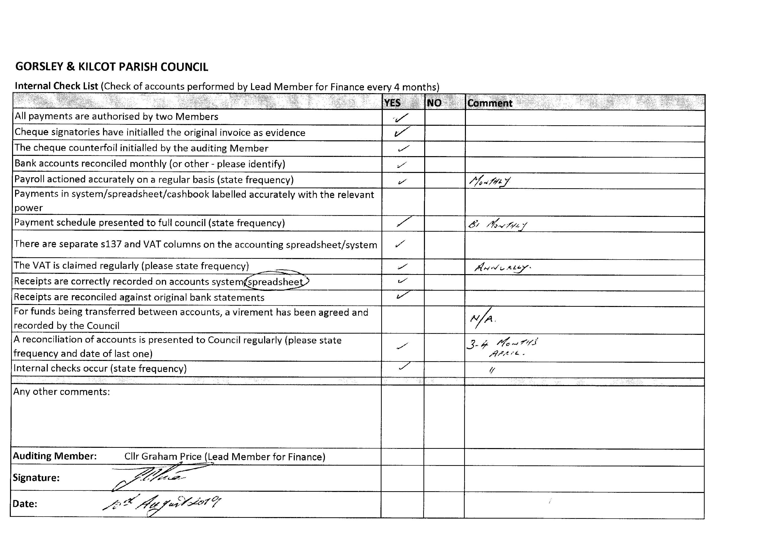
51.3
Bank Reconciliation
Name of smaller authority: | Gorsley & Kilcot Parish Council
Date: | 30 July 2019
Prepared by (Name and Role): | Arin Spencer (RFO)
Date: | 06/08/2019
 |  | £ | £
Balance per bank statement as at 30/07/2019:
The co-operative bank |  | 11,504.01
 |  |  | 11,504.01
Less: Unpresented cheques as at 30/07/2019
A. Spencer (Expenses) | 100017 | - 40.16
GRCC Subscription | 100018 | - 25.00
GAPTC Internal Audit | 100019 | - 175.75
 |  |  | - 240.91
Net balances as at 30/07/2019 |  |  | 11,263.10

51.4 Receipts and Payments Account
 | Note | Budget 2019/20 | YTD Total 2019/20 | Total 2018/19
 |  | £ | £ | £
Co-op Bank Balance b/f 01/04/2019 | 1 |  | 7,560.19 | 8,247.19
RECEIPTS
Precept |  |  | 5,547.00 | 5,385.00
Wayleave re Electricity Poles |  |  |  | 19.15
VAT Refund |  |  |  | 656.49
TOTAL RECEIPTS |  | - | 13,107.19 | 14,307.83
PAYMENTS
Mileage / Home Allowance |  | 350.00 | 69.66
Salaries |  | 2,353.92 | 784.64
Staff Costs |  | 2,703.92 | 854.30 | 4,757.02
Stationery / Postage |  | 120.00 | 7.60 | 24.37
Newsletter |  | 90.00 | - | 45.00
Insurance |  | 190.00 | 168.06 | 183.57
Audit |  | 185.00 | 175.75 | 174.85
Subscriptions | 2 | 265.00 | 144.45 | 296.08
Room Hire |  | 255.00 | - | 260.00
Chairmans Allowance |  | 100.00 | - | 1.95
Website |  | 100.00 | 19.98
Administration |  | 1,305.00 | 515.84 | 985.82
Councillors' Mileage |  | 50.00 | -
Training |  | 400.00 | 25.00 | 231.49
New Laptop Computer |  | - | 323.99
Laptop Software |  | - | 30.00
Grants & Donations |  | 100.00 | -
Election Expenses |  | 146.00 | -
APM Expenses |  | 25.00 | - | 23.15
Advertisement for new Clerk |  | - | - | 46.80
Other |  | 721.00 | 378.99 | 301.44
Work on Kilcot Green |  | 750.00 | - | -
Registration |  | - | - | 580.00
Amenities |  | 750.00 | - | 580.00
S137 Expenditure |  | - | - | -
VAT |  | - | 94.96 | 123.36
Total Payments |  | 5,479.92 | 1,844.09 | 6,747.64
Bank Reconciliation
Balance b/f 01/04/2019 |  |  | 7,560.19 | 8,247.19
Receipts |  |  | 5,547.00 | 6,060.64
 |  |  | 13,107.19 | 14,307.83
Payments |  |  | 1,844.09 | 6,747.64
Balance c/f 30/07/2019 |  |  | 11,263.10 | 7,560.19
51.5 Budget Monitoring Statement
GORSLEY & KILCOT PARISH COUNCIL
Budget Monitoring Statement as at 30/07/2019
Description | Budget | YTD | Remaining | Projected | Est. under/ | Notes
 | 2019/2020 | Spend | Budget | year end | over spend
Mileage/Home Allowance | 350.00 | 69.66 | 280.34 | 238.30 | 111.70 | 1
Salaries | 2,353.92 | 784.64 | 1,569.28 | 2,353.92 | -
Staff Costs | 2,703.92 | 854.30 | 1,849.62 | 2,592.22 | 111.70
Stationery/Postage | 120.00 | 7.60 | 112.40 | 40.00 | 80.00
Newsletter | 90.00 | - | 90.00 | 90.00 | -
Insurance | 190.00 | 168.06 | 21.94 | 168.06 | 21.94 | 2
Audit | 185.00 | 175.75 | 9.25 | 175.75
Subscriptions | 265.00 | 144.45 | 120.55 | 168.45 | 96.55
Room Hire | 255.00 | - | 255.00 | 255.00 | -
Chairman’s Allowance | 100.00 | - | 100.00 | - | 100.00
Website | 100.00 | 19.98 | 80.02 | 55.98 | 44.02 | 3
Administration | 1,305.00 | 515.84 | 789.16 | 953.24 | 342.51
Counciller's Mileage | 50.00 | - | 50.00 | - | 50.00
Training | 400.00 | 25.00 | 375.00 | 159.00 | 241.00 | 4
Laptop Computer | - | 323.99 | - 323.99 | 323.99 | - 323.99
Microsoft Office 365 | - | 30.00 | - 30.00 | 30.00 | - 30.00 | 5
Grants & Donations | 100.00 | - | 100.00 | - | 100.00
Election Expenses | 146.00 | - | 146.00 | - | 146.00
APM Expenses | 25.00 | - | 25.00 | 25.00 | -
Other | 721.00 | 378.99 | 342.01 | 537.99 | 183.01
Work on Kilcot Green | 750.00 | - | 750.00 | 750.00 | -
Registration | - | - | -
Amenities | 750.00 | - | 750.00 | 750.00 | -
Contingency | 300.00 | - | 300.00 | - | 300.00
S137 | - | - | - | -
VAT | - | 94.96 |  | 94.96
TOTAL EXPENDITURE | 5,779.92 | 1,844.09 | 4,030.79 | 4,928.41 | 937.22 | 6
NOTES:
1. £69.66 + (£17.33 home allowance x 8 months) + £30 mileage estimate = £238.30
2. Budgeted figure includes VAT.
3. Domain £19.98 + £6 x 6 months monthly fee for wordpress essential managed package (1&1 Ionos)
4. £25 + £95 councillor training + £39 clerk training = £159
5. Microsoft Office 365 required for new laptop
6. Grants & Donations Reserve |  | £ 100.00
Elections Reserve |  | £ 146.00
Projected Underspend |  | £ 691.22
 |  | £ 937.22
52. Draft Budget 2020/2021
Description | BUDGET | Year to Date | Year End | BUDGET | Notes
 | 2018/2019 | Expenditure | Forecast | 2019/2020
Mileage/Home Allowance | 350.00 | 69.66 | 238.30 | 295.00 | 1
Salaries | 2,353.92 | 784.64 | 2,353.92 | 2,490.00 | 2
Staff Costs | 2,703.92 | 854.30 | 2,592.22 | 2,785.00
Stationery/Postage | 120.00 | 7.60 | 40.00 | 100.00 | 3
Newsletter | 90.00 | - | 90.00 | 90.00
Insurance | 190.00 | 168.06 | 168.06 | 170.00 | 4
Audit | 185.00 | 175.75 | 175.75 | 185.00
Subscriptions | 265.00 | 144.45 | 168.45 | 185.00 | 5
Room Hire | 255.00 | - | 255.00 | 265.00
Chairman’s Allowance | 100.00 | - | - | 100.00
Website | 100.00 | 19.98 | 55.98 | 72.00 | 6
Administration | 1,305.00 | 515.84 | 953.24 | 1,167.00
Councillor's Mileage | 50.00 | - | - | 50.00
Training | 400.00 | 25.00 | 159.00 | 300.00
Laptop Computer | - | 323.99 | 323.99 | -
Microsoft Office 365 | - | 30.00 | 30.00 | 20.00
Antivirus Software | - | 11.60 | 11.60 | 20.00
Grants & Donations | 100.00 | - | - | 125.00
Election Expenses | 146.00 | - | - | 300.00 | 7
APM Expenses | 25.00 | - | 25.00 | 30.00
Other | 721.00 | 390.59 | 549.59 | 845.00
Work on Kilcot Green | 750.00 | - | 750.00 | 750.00
Registration | - | - | - | -
Amenities | 750.00 | - | 750.00 | 750.00
Contingency | 300.00 | - | - | -
S137 | - | - | - | -
VAT | - | 94.96 | 94.96 | -
TOTAL EXPENDITURE | 5,779.92 | 1,855.69 | 4,940.01 | 5,547.00 | 8
NOTES:
1. Home Working Allowance: |  | £18 x 12 months = |  | £ 216.00
Mileage: |  |  |  | £ 80.00
 |  |  |  | £ 296.00
2. NALC LC1 SCP 8 | £10.37/hour x 20 hours/month x 12 months = |  |  | £ 2,488.80
3. Stationery: |  |  |  | £ 20.00
Printing: | £5/month x 12 |  |  | £ 60.00
Postage: | 3 x £0.61 2nd class stamps x 12 months |  |  | £ 21.96
 |  |  |  | £ 101.96
4. Third year of three year fixed premium insurance contract |  |  |  | £ 168.06
5. Subscriptions |  |  |  | Ex VAT | VAT
 | GAPTC Annual Subscription |  |  | £ 72.45 | £ -
 | Parish Online |  |  | £ 30.00 | £ 6.00
 | NALC LCR Magazine |  |  | £ 17.00 | £ -
 | GRCC Annual Subscription |  |  | £ 25.00 | £ -
 | Society of Local Council Clerks |  |  | £ 40.00 | £ -
 |  |  |  | £ 184.45 | £ 6.00
6. 1&1 Ionos Managed WordPress: |  | £6 * 12 months |  | £ 72.00
7. Election Reserve - towards provision for £1200 in the event of a contested election in 2023
8. Precept remains unchanged at |  |  |  | £ 5,547.00

54. HGV THROUGH TRAFFIC ON B4221
A letter was sent to Local Highways Manager Andrew Middlecote querying how the HGV traffic data available could be used to identify
- local vs through traffic and
- HGV traffic using the B4222 (where Council would like to see a weight limit imposed)

Highways sent up to date HGV data from the B4221 traffic counter but advised that there is “no continuous data collection from the B4222, last count is from 2005. With limited resources, our traffic count sites are limited to strategic sites only. In order to obtain local and through traffic, the only way of collecting this data would be to carry out origin and destination surveys or interview surveys. If Parish funding is available…surveys (can) be arranged.”

56.2 NALC Tree Charter
The Charter for Trees, Woods and People sets out the principles for a society in which people and trees can stand stronger together. The Tree Charter was launched in Lincoln Castle on 6 November 2017; the 800th anniversary of the 1217 Charter of the Forest. The Tree Charter is rooted in more than 60,000 ‘tree stories’ gathered from people of all backgrounds across the UK. https://treecharter.uk/

The 10 Tree Charter Principles

