Gorsley & Kilcot Parish Council

Chairman: Councillor Nigel Warwick

Clerk: Mrs Arin Spencer ▪ M: 07484 619582

Email: clerk@gkpc.co.uk ▪ Website: www.gkpc.co.uk

MINUTES OF THE MEETING OF GORSLEY & KILCOT PARISH COUNCIL
Held on Monday 2nd September 2019 at 7:30pm in the Upper Room Christ Church, Gorsley

Present: Cllr Nigel Warwick (Chairman), Cllr David Clough (Vice-Chairman), Cllr Graham Price, Cllr Steve Excell, Cllr Catherine Gardner, Cllr John Barker

In attendance: Mrs Arin Spencer (Clerk)

- Apologies for Absence
Received apologies for absence from Cllr Nigel Poole
- Declarations of Interest and Requests for Dispensation. None received.
- Minutes
Resolved: Approved and signed the minutes of the Council meeting held on 1st July 2019 as a correct record nem. con.
- Financial Matters:
  - Cllr Price, Lead Member for Finance, reported that he had performed an internal check of the accounts for the period April to July 2019 and found them to be in order.
  - Resolved: Noted Co-op Bank Statement dated 30/07/2019 showing a balance of £11,504.01 nem. con.
  - Resolved: Received and signed Bank Reconciliation as at 30/07/2019 nem. con.
  - Resolved: Approved Receipts & Payments Account as at 30/07/2019 nem. con.
  - Resolved: Noted Budget Monitoring Statement as at 30/07/2019 nem. con.
  - Resolved: Approved the following payments nem. con.:
Description | Chq No | Power | Budget | Amount
Clerk’s Salary (July) | SO | LGA 1972 s112(2) | Staff Costs | £ 196.16
Clerk’s Salary (August) | SO | LGA 1972 s112(2) | Staff Costs | £ 196.16
Clerk’s Expenses | 100020 | LG(FP)A 1963 S 5 | Staff Costs | £ 50.61
- Budget 2020/2021
  - Considered draft Budget for 2020/21
Action: Councillors to consider items for inclusion in the budget and send to the Clerk prior to the November meeting.
- Planning Matters:
  - Considered the following new planning applications received:
    - P0953/19/FUL Quarry Farm, Aston Ingham Road, Kilcot, Newent
Proposal: Construction of an equestrian manège
Resolved: No objection nem. con.
  - Noted the following planning decisions:
    - P0750/19/FUL Orchard House, Aston Ingham Road, Kilcot GL18 1NP
Decision: Granted Permission

- Traffic problems on the B4221
Speeding on B4221
Cllr Warwick reported to Council on the Road Speed and Road Safety meeting held by Linton Parish Council on 03/07/2019 (notes available on request).
Weight Limit on B4222
Implementation of a weight limit on the B4222 is on the Balfour Beatty Living Places list and currently working its way to the top. Cllr Warwick proposed that council contact Gloucestershire Highways about a joint traffic regulation for the B4222 with the cost to be split between Gloucestershire and Herefordshire.
Cllr Price observed that there has been significant opposition from Gloucestershire Highways to this proposal in the past.
It was agreed that Council will wait for Herefordshire to get to the point where they are ready to implement the weight limit and then lobby Gloucestershire Highways to implement a weight limit on the B4222 from the county boundary to the B4221. (The Herefordshire side of the B4222 already has a sign that says “Unsuitable for HGVs” but this does not deter HGVs coming onto it from the B4221).
HGV Traffic on B4221/B4222
A letter was sent to Local Highways Manager Andrew Middlecote querying how the HGV traffic data available could be used to identify
- local vs through traffic and
- HGV traffic using the B4222 (where Council would like to see a weight limit imposed)
Highways sent up to date HGV data from the B4221 traffic counter but advised that there is “no continuous data collection from the B4222, last count is from 2005. With limited resources, our traffic count sites are limited to strategic sites only. In order to obtain local and through traffic, the only way of collecting this data would be to carry out origin and destination surveys or interview surveys. If Parish funding is available…surveys (can) be arranged.”
Cllr Warwick noted that the Local Transport Plan will be reviewed in 2020 which will be an opportunity for Council to raise the issue of HGV traffic again.
Speedwatch
Action: Clerk to set up Speedwatch as soon as can be arranged.
- Registration of Common Land – Aston Common
Cllr Warwick summarised the position for new councillors not familiar with the history. Council has tried to register ownership of Aston Common. Despite having met its obligations for ownership, Council was told it has not done enough to register the land and needs to evidence 12 years of working the land before it can register ownership.
Nothing is being done on the land and to get it sorted out will cost a lot of money. Councillors were invited to submit ideas on what could be done with the land. No proposals were immediately forthcoming.
- Tree Safety
Cllr Warwick reported to Council that the Clerk had provided several examples of tree policies ranging from one page to 65 pages. He recommended using the one page policy but incorporating elements from the other policies to create a proportionate policy for Gorsley & Kilcot Parish Council.
Action: Cllr Warwick to draft a Tree Safety Policy and circulate to councillors for consideration at the November meeting.
  - NALC Tree Charter
Resolved: To sign up to the NALC Tree Charter nem. con. https://treecharter.uk/
- Kilcot Green Noticeboard
Cllr Warwick has removed the rotten back of the noticeboard. Further attempts to repair it may make the noticeboard unsalvageable.
Action: Cllr Warwick to continue with attempt to salvage the noticeboard. Council accepts the risk that it could become unsalvageable in the process.
- Community First Aid Course
Action: Clerk to make necessary arrangements to host a free community first aid course.
- New WordPress Council Website
Action: Clerk to rebuild Council’s website in WordPress using 1&1 Ionos WordPress Essential package at a cost of £6/month excl VAT.
- Training
Resolved: Approved the following GAPTC training schedule for the Clerk nem. con.:
  - Budget Planning & Precept Setting (16-10-19) £15
  - Planning applications from the perspective of town and parish councils (20-11-19) £17
  - Clerk’s Networking with 2 guest speakers (27-11-19) £7
- Clerks Report – FOR INFORMATION ONLY
Received a report from the Clerk on actions requested in the minutes dated 1st July 2019 not covered elsewhere in the agenda including action tracker.
- Considered attending the following meetings/events:
  - CPRE AGM 12 September 2019 at 18:30 in Westbury-on-Severn church
Resolved: Not to attend.
  - Dementia Action Alliance Celebration Event 27 September 2019 (GL16 7QT)
Resolved: Not to attend.
- To RECEIVE items for the November meeting agenda
Kilcot Wood Maintenance
Speedwatch
- Next meeting
To CONFIRM that the next ordinary meeting of the Parish Council will be held on 4 November 2019 at 7:30pm in the Upper Room at Christ Church, Gorsley.

With no further business the meeting was closed at 20:43

Signed (Chairman) Date:

51.1 REPORT: Internal Accounts Check (April – July 2019)
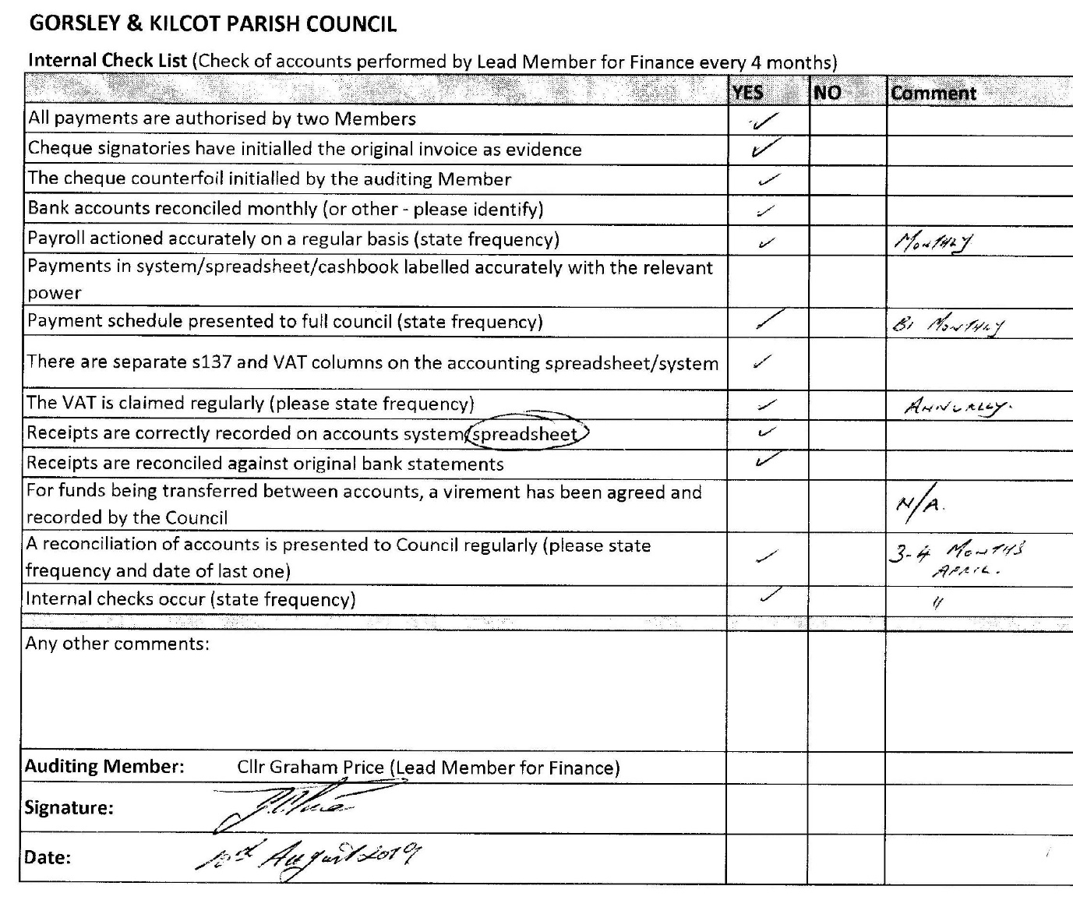

51.3
Bank Reconciliation
Name of smaller authority: | Gorsley & Kilcot Parish Council
Date: | 30 July 2019
Prepared by (Name and Role): | Arin Spencer (RFO)
Date: | 06/08/2019
 |  | £ | £
Balance per bank statement as at 30/07/2019:
The co-operative bank |  | 11,504.01
 |  |  | 11,504.01
Less: Unpresented cheques as at 30/07/2019
A. Spencer (Expenses) | 100017 | - 40.16
GRCC Subscription | 100018 | - 25.00
GAPTC Internal Audit | 100019 | - 175.75
 |  |  | - 240.91
Net balances as at 30/07/2019 |  |  | 11,263.10

51.4 Receipts and Payments Account
 | Note | Budget 2019/20 | YTD Total 2019/20 | Total 2018/19
 |  | £ | £ | £
Co-op Bank Balance b/f 01/04/2019 | 1 |  | 7,560.19 | 8,247.19
RECEIPTS
Precept |  |  | 5,547.00 | 5,385.00
Wayleave re Electricity Poles |  |  |  | 19.15
VAT Refund |  |  |  | 656.49
TOTAL RECEIPTS |  | - | 13,107.19 | 14,307.83
PAYMENTS
Mileage / Home Allowance |  | 350.00 | 69.66
Salaries |  | 2,353.92 | 784.64
Staff Costs |  | 2,703.92 | 854.30 | 4,757.02
Stationery / Postage |  | 120.00 | 7.60 | 24.37
Newsletter |  | 90.00 | - | 45.00
Insurance |  | 190.00 | 168.06 | 183.57
Audit |  | 185.00 | 175.75 | 174.85
Subscriptions | 2 | 265.00 | 144.45 | 296.08
Room Hire |  | 255.00 | - | 260.00
Chairmans Allowance |  | 100.00 | - | 1.95
Website |  | 100.00 | 19.98
Administration |  | 1,305.00 | 515.84 | 985.82
Councillors' Mileage |  | 50.00 | -
Training |  | 400.00 | 25.00 | 231.49
New Laptop Computer |  | - | 323.99
Laptop Software |  | - | 30.00
Grants & Donations |  | 100.00 | -
Election Expenses |  | 146.00 | -
APM Expenses |  | 25.00 | - | 23.15
Advertisement for new Clerk |  | - | - | 46.80
Other |  | 721.00 | 378.99 | 301.44
Work on Kilcot Green |  | 750.00 | - | -
Registration |  | - | - | 580.00
Amenities |  | 750.00 | - | 580.00
S137 Expenditure |  | - | - | -
VAT |  | - | 94.96 | 123.36
Total Payments |  | 5,479.92 | 1,844.09 | 6,747.64
Bank Reconciliation
Balance b/f 01/04/2019 |  |  | 7,560.19 | 8,247.19
Receipts |  |  | 5,547.00 | 6,060.64
 |  |  | 13,107.19 | 14,307.83
Payments |  |  | 1,844.09 | 6,747.64
Balance c/f 30/07/2019 |  |  | 11,263.10 | 7,560.19

51.5 Budget Monitoring Statement
GORSLEY & KILCOT PARISH COUNCIL
Budget Monitoring Statement as at 30/07/2019
Description | Budget | YTD | Remaining | Projected | Est. under/ | Notes
 | 2019/2020 | Spend | Budget | year end | over spend
Mileage/Home Allowance | 350.00 | 69.66 | 280.34 | 238.30 | 111.70 | 1
Salaries | 2,353.92 | 784.64 | 1,569.28 | 2,353.92 | -
Staff Costs | 2,703.92 | 854.30 | 1,849.62 | 2,592.22 | 111.70
Stationery/Postage | 120.00 | 7.60 | 112.40 | 40.00 | 80.00
Newsletter | 90.00 | - | 90.00 | 90.00 | -
Insurance | 190.00 | 168.06 | 21.94 | 168.06 | 21.94 | 2
Audit | 185.00 | 175.75 | 9.25 | 175.75
Subscriptions | 265.00 | 144.45 | 120.55 | 168.45 | 96.55
Room Hire | 255.00 | - | 255.00 | 255.00 | -
Chairman’s Allowance | 100.00 | - | 100.00 | - | 100.00
Website | 100.00 | 19.98 | 80.02 | 55.98 | 44.02 | 3
Administration | 1,305.00 | 515.84 | 789.16 | 953.24 | 342.51
Counciller's Mileage | 50.00 | - | 50.00 | - | 50.00
Training | 400.00 | 25.00 | 375.00 | 159.00 | 241.00 | 4
Laptop Computer | - | 323.99 | - 323.99 | 323.99 | - 323.99
Microsoft Office 365 | - | 30.00 | - 30.00 | 30.00 | - 30.00 | 5
Grants & Donations | 100.00 | - | 100.00 | - | 100.00
Election Expenses | 146.00 | - | 146.00 | - | 146.00
APM Expenses | 25.00 | - | 25.00 | 25.00 | -
Other | 721.00 | 378.99 | 342.01 | 537.99 | 183.01
Work on Kilcot Green | 750.00 | - | 750.00 | 750.00 | -
Registration | - | - | -
Amenities | 750.00 | - | 750.00 | 750.00 | -
Contingency | 300.00 | - | 300.00 | - | 300.00
S137 | - | - | - | -
VAT | - | 94.96 |  | 94.96
TOTAL EXPENDITURE | 5,779.92 | 1,844.09 | 4,030.79 | 4,928.41 | 937.22 | 6
NOTES:
1. £69.66 + (£17.33 home allowance x 8 months) + £30 mileage estimate = £238.30
2. Budgeted figure includes VAT.
3. Domain £19.98 + £6 x 6 months monthly fee for wordpress essential managed package (1&1 Ionos)
4. £25 + £95 councillor training + £39 clerk training = £159
5. Microsoft Office 365 required for new laptop
6. Grants & Donations Reserve |  | £ 100.00
Elections Reserve |  | £ 146.00
Projected Underspend |  | £ 691.22
 |  | £ 937.22

52. Draft Budget 2020/2021
Description | BUDGET | Year to Date | Year End | BUDGET | Notes
 | 2018/2019 | Expenditure | Forecast | 2019/2020
Mileage/Home Allowance | 350.00 | 69.66 | 238.30 | 295.00 | 1
Salaries | 2,353.92 | 784.64 | 2,353.92 | 2,490.00 | 2
Staff Costs | 2,703.92 | 854.30 | 2,592.22 | 2,785.00
Stationery/Postage | 120.00 | 7.60 | 40.00 | 100.00 | 3
Newsletter | 90.00 | - | 90.00 | 90.00
Insurance | 190.00 | 168.06 | 168.06 | 170.00 | 4
Audit | 185.00 | 175.75 | 175.75 | 185.00
Subscriptions | 265.00 | 144.45 | 168.45 | 185.00 | 5
Room Hire | 255.00 | - | 255.00 | 265.00
Chairman’s Allowance | 100.00 | - | - | 100.00
Website | 100.00 | 19.98 | 55.98 | 72.00 | 6
Administration | 1,305.00 | 515.84 | 953.24 | 1,167.00
Councillor's Mileage | 50.00 | - | - | 50.00
Training | 400.00 | 25.00 | 159.00 | 300.00
Laptop Computer | - | 323.99 | 323.99 | -
Microsoft Office 365 | - | 30.00 | 30.00 | 20.00
Antivirus Software | - | 11.60 | 11.60 | 20.00
Grants & Donations | 100.00 | - | - | 125.00
Election Expenses | 146.00 | - | - | 300.00 | 7
APM Expenses | 25.00 | - | 25.00 | 30.00
Other | 721.00 | 390.59 | 549.59 | 845.00
Work on Kilcot Green | 750.00 | - | 750.00 | 750.00
Registration | - | - | - | -
Amenities | 750.00 | - | 750.00 | 750.00
Contingency | 300.00 | - | - | -
S137 | - | - | - | -
VAT | - | 94.96 | 94.96 | -
TOTAL EXPENDITURE | 5,779.92 | 1,855.69 | 4,940.01 | 5,547.00 | 8
NOTES:
1. Home Working Allowance: |  | £18 x 12 months = |  | £ 216.00
Mileage: |  |  |  | £ 80.00
 |  |  |  | £ 296.00
2. NALC LC1 SCP 8 | £10.37/hour x 20 hours/month x 12 months = |  |  | £ 2,488.80
3. Stationery: |  |  |  | £ 20.00
Printing: | £5/month x 12 |  |  | £ 60.00
Postage: | 3 x £0.61 2nd class stamps x 12 months |  |  | £ 21.96
 |  |  |  | £ 101.96
4. Third year of three year fixed premium insurance contract |  |  |  | £ 168.06
5. Subscriptions |  |  |  | Ex VAT | VAT
 | GAPTC Annual Subscription |  |  | £ 72.45 | £ -
 | Parish Online |  |  | £ 30.00 | £ 6.00
 | NALC LCR Magazine |  |  | £ 17.00 | £ -
 | GRCC Annual Subscription |  |  | £ 25.00 | £ -
 | Society of Local Council Clerks |  |  | £ 40.00 | £ -
 |  |  |  | £ 184.45 | £ 6.00
6. 1&1 Ionos Managed WordPress: |  | £6 * 12 months |  | £ 72.00
7. Election Reserve - towards provision for £1200 in the event of a contested election in 2023
8. Precept remains unchanged at |  |  |  | £ 5,547.00

