6

Councillors are hereby summoned to attend a Meeting of GORSLEY & KILCOT PARISH COUNCIL to be held at 7:30pm on Monday 4th November 2019 in the Upper Room at Christ Church, Gorsley for the purpose of transacting the following business.
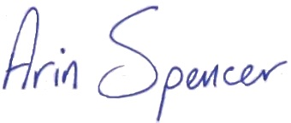

Arin Spencer (Mrs) Dated 30 October 2019
Clerk to Gorsley & Kilcot Parish Council

Members of the Public are invited to address the Council at 7:30pm on matters on the agenda. (Public to speak for a maximum of 3 minutes each with the Public Session being no longer than 30 minutes).
AGENDA

- To receive Apologies for Absence
- To receive Declarations of Interest and Requests for Dispensation regarding items on the agenda
- To receive feedback from Cheltenham Motor Club on Three Shires Stages Rally
- To approve and sign the minutes of the Council meeting held on 7th October 2019 as a correct record.
- Planning Matters:
  - To comment on new planning applications received:
    - P1555/19/FUL Hartleys Barn, Ross Road, Gorsley
Proposal: Conversion of garage to annexe ancillary to main dwelling including associated works.
Deadline: 06 November 2019
  - To note planning appeal decisions:
  - APP/P1615/Y/19/3228936 - P0147/19/LBC - Briery Hill House, Kilcot, Newent
Proposal: Listed Building Consent for the proposed replacement of windows in north east elevation and repainting of all other windows.
Decision: The appeal is allowed in part (repainting of windows) but is otherwise dismissed (replacement windows)
- Highways
  - To discuss traffic problems on the B4221
  - To discuss the Local Transport Plan
  - To confirm Speedwatch Rota for 23 November to 6 December
- Footpaths
  - To note Public Path Diversion and Definitive Map and Statement Modification Order in respect of public footpath GGK 36 (Appendix 1)
- To discuss Registration of Common Land – Aston Common
- To consider maintenance work required in Kilcot Wood
- To consider signing the Gloucestershire Charter (Appendix 2)

- Financial Matters:
  - To note Co-op Bank Statement dated 30/09/2019 reflecting a balance of £10,820.17
  - To note Bank Reconciliation as at 30/09/2019
  - To note Budget Monitoring Statement as at 30/09/2019
  - To approve the following payments:
Description | Chq No | Power | Budget | Amount
Clerk’s Salary (Sept) | SO | LGA 1972 s112(2) | Staff Costs | £ 196.16
GAPTC Training | 100021 | LGA 1972 s111 | Cllr Training | £ 95.00
FoDDC | 100022 | RPA 1983 s36(5) | Election | £ 147.00
Clerk’s Salary (Oct) | SO | LGA 1972 s112(2) | Staff Costs | £ 196.16
Clerk’s Expenses | 100023 | LG(FP)A 1963 S 5 | Staff Costs | £ 28.24
GAPTC Training | 100024 | LGA 1972 s111 | Clerk Training | £ 15.00
- Clerks Report – FOR INFORMATION ONLY
To RECEIVE a report from the Clerk on actions requested in the minutes dated 7th October not covered elsewhere in the agenda including action tracker
- To note list of correspondence received
Gloucestershire Environmental Trust – The Final Report: 1997-2019
Creative Play – The Outdoor Play Experts (Brochure)
Clerks & Councils Direct – July 2019
- To consider attending the following meetings/events:
  - Cyber Security presentation by Gloucestershire Police on 13/11/19 at 10am in Bream
  - GRCC Road Safety Event on 14/11/19 from 6-8pm in Northleach
  - Stagecoach Briefing with District Cllr Paul Hiet on 18/11/19 at 6pm in Coleford
  - Solar Streets Project Presentation on 27/11/19 at 6pm at FoDDC in Coleford
- To receive items for the January meeting agenda
- Next meeting
To CONFIRM that the next ordinary meeting of the Parish Council will be held on 4 November 2019 at 7:30pm in the Upper Room at Christ Church, Gorsley.

PLANNING APPLICATIONS WILL BE AVAILABLE FOR VIEWING BY THE PUBLIC FROM 15 MINUTES PRIOR TO THE MEETING AND BY APPOINTMENT WITH THE CLERK (Mrs Arin Spencer 07484619582) AT CHRIST CHURCH GORSLEY
ALL MEETINGS OF THE COUNCIL ARE OPEN TO THE PUBLIC AND PRESS WITH THE EXCEPTION OF ITEMS CONSIDERED UNDER STANDING ORDER 1C
All meetings can be moved downstairs if stairs are an obstacle to attendance at a meeting or a Loop System is required. A wheelchair ramp can be provided to access the church.
“Members are reminded that the Council has a general duty to consider the following matters in the exercise of any of its functions: Equal Opportunities (race, sexual orientation, marital status and any disability), Crime and Disorder, Biodiversity, Health and Safety and Human Rights.”
APPENDIX 1
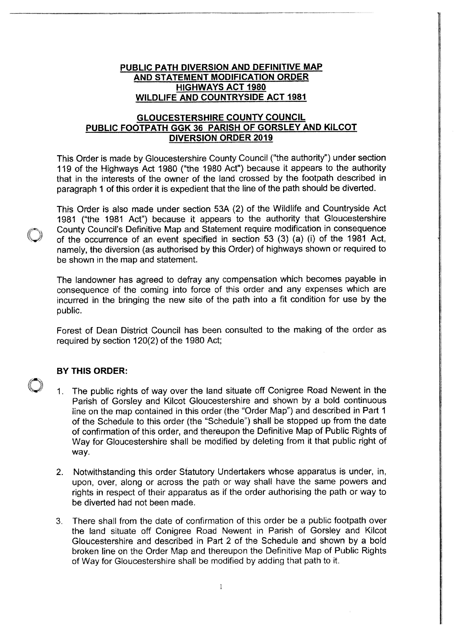

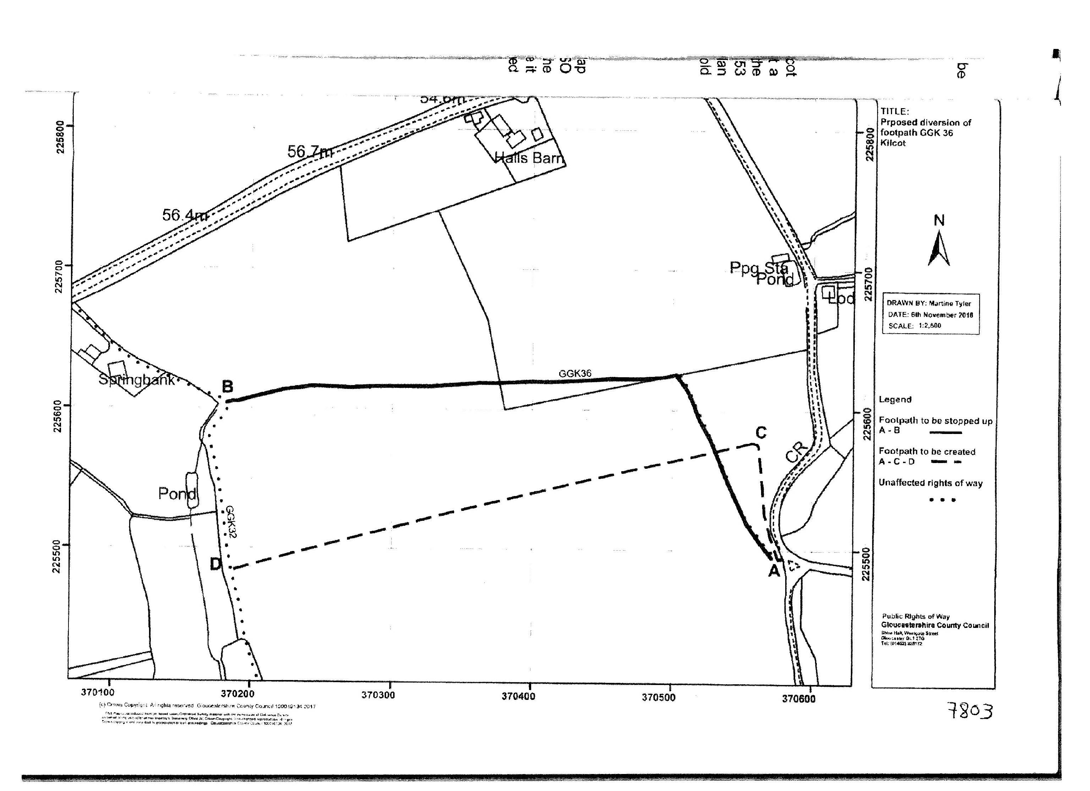

APPENDIX 2

